# Brainstorm

**TIP**

You can select a sticky note and hit the pencil [switch to sketch] icon to start drawing!

## Before you collaborate

A little bit of preparation goes a long way with this session. Here’s what you need to do to get going.

**10 minutes**

**1**

## Define your problem statement

What problem are you trying to solve? Frame your problem as a How Might We statement. This will be the focus of your brainstorm.

**5 minutes**

**2**

## Brainstorm

Write down any ideas that come to mind that address your problem statement.

**10 minutes**

**3**

## Group ideas

Take turns sharing your ideas while clustering similar or related notes as you go. Once all sticky notes have been grouped, give each cluster a sentence-like label. If a cluster is bigger than six sticky notes, try and see if you and break it up into smaller sub-groups.

**20 minutes**

Alertment about nearest containment zones.

**4 **

## Prioritize

Your team should all be on the same page about what's important moving forward. Place your ideas on this grid to determine which ideas are important and which are feasible.

**20 minutes**

Helpline numbers

# & idea prioritization

Highlighted zones based on the degree of the infectious zones

### Use this template in your own brainstorming sessions so your team can unleash their imagination and start shaping concepts even if you're not sitting in the same room.

**10 minutes** to prepare

**1 hour** to collaborate

**2-8 people** recommended

1. **Team gathering**

Define who should participate in the session and send an invite. Share relevant information or pre-work ahead.

1. **Set the goal**

Think about the problem you'll be focusing on solving in the brainstorming session.

1. **Learn how to use the facilitation tools**

Use the Facilitation Superpowers to run a happy and productive session.

[**Open article**](https://support.mural.co/en/articles/2113740-facilitation-superpowers)

**PROBLEM**

How to alert the user if they come near to the containment zones

#### Key rules of brainstorming

User must keep updated of their app for better reliable of data

Alerting people 500meters before reaching the zones

Alerting people 500meters before reaching the zones

Location tracking

To run an smooth and productive session

### Sheik

### 

|  |
| --- |
| Admins can |
| monitor user's |
| continous |
| movements |

User's vaccination details

KaviYarasan A

### Dhesingu

Updates based on data given by government regarding containment zones.

Alerts are notified via SMS using mobile number given.

### TrAckinG of user

GPS Tracking of location

Cellular triangulation for tracking

ALERT USER

Alerting people 500 meters before reaching the containment zones

24/7

monitoring of affected zone and alerting it

Highlighted zones based on the degree of the infectious zones

Stay in topic. Defer judgment.

Encourage wild ideas. Listen to others.

#### Importance

Notify on visited zone removed from containment zones

To make the user easily access we can provide Covid statistics on a bottom sheet in Google Map

Containment zone shown in the google map

Alerts are notified via SMS using mobile number given

To detect the radius using Cloud Firestore

Android's geofencing client is used to create geofences around the containment zones

If each of these

Hospital Bed Allocation

Go for volume. If possible, be visual.

### Zone identificAtion

Helpline numbers

User information

Cloud

Hospital Bed Allocation

Daily Covid cases

tasks could get

done without any difficulty or cost, which would have the most positive impact?

### Velmurugan C

### Sri Kanth K

Alters are notified via SMS using mobile number given.

24/7

Monitoring of affected zone and alerting it

Daily Covid cases

Highlighted containment zones

Updates based on government database

Notification of entering containment zone

Sharing of the status

Notify on visited zone removed from containment zones

Minimal mobile knowledge is required to use the app

User can share the status as public whether they affected or not

User must keep updated of their app for better reliable of data

[**Share template feedback**](https://muralco.typeform.com/to/CiqaHVat?typeform-source=app.mural.co)

#### Feasibility

Regardless of their importance, which tasks are more feasible than others? (Cost, time, effort, complexity, etc.)

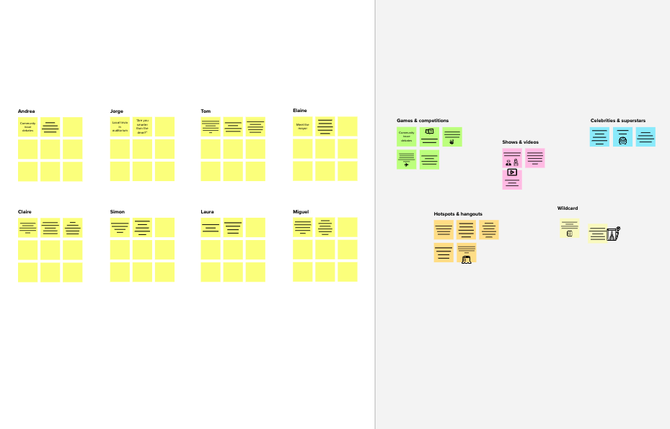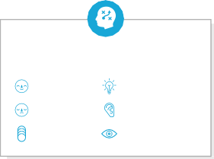

[**Share template feedback**](https://muralco.typeform.com/to/CiqaHVat?typeform-source=app.mural.co)

**Keep moving forward**

**Strategy blueprint**

Define the components of a new idea or strategy.

[**Open the template**](https://app.mural.co/template/e95f612a-f72a-4772-bc48-545aaa04e0c9/984865a6-0a96-4472-a48d-47639307b3ca)

**Customer experience journey map**

Understand customer needs, motivations, and obstacles for an experience.

[**Open the template**](https://app.mural.co/template/b7114010-3a67-4d63-a51d-6f2cedc9633f/c1b465ab-57af-4624-8faf-ebb312edc0eb)

**Strengths, weaknesses, opportunities & threats**

Identify strengths, weaknesses, opportunities, and threats (SWOT) to develop a plan.

[**Open the template**](https://app.mural.co/template/6a062671-89ee-4b76-9409-2603d8b098be/ca270343-1d54-4952-9d8c-fbc303ffd0f2)

**Quick add-ons**

1. **Share the mural**

**Share a view link** to the mural with stakeholders to keep them in the loop about the outcomes of the session.

1. **Export the mural**

Export a copy of the mural as a PNG or PDF to attach to emails, include in slides, or save in your drive.

**After you collaborate**

You can export the mural as an image or pdf to share with members of your company who might find it helpful.

**Template**

**Need some inspiration?**

To detect the radius using Cloud Firestore

24/7

Monitoring of affected zone and alerting it

To make the user easily access we can provide Covid statistics on a bottom sheet in Google Map

Using information from hospital and take data analysis and allocate zone

See a finished version of this template to kickstart your work.

[**Open example**](https://app.mural.co/template/e5a93b7b-49f2-48c9-afd7-a635d860eba6/93f1b98d-b2d2-4695-8e85-7e9c0d2fd9b9)